Farmers Bank of Appomattox Online Banking – First Time User Enrollment (Mobile App)

You may complete your initial enrollment either via web browser or directly from the mobile app if you intend to log in primarily from your phone. If you intend to start with the mobile login, you may wish to skip to page 4 section Mobile Setup. To enroll via web browser, follow the steps below.
- Visit www.thefarmersbankva.com, click Login near the upper right corner of the screen, and use the Click here to enroll now link.
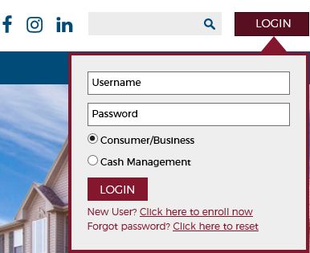

- Complete the enrollment form with your information 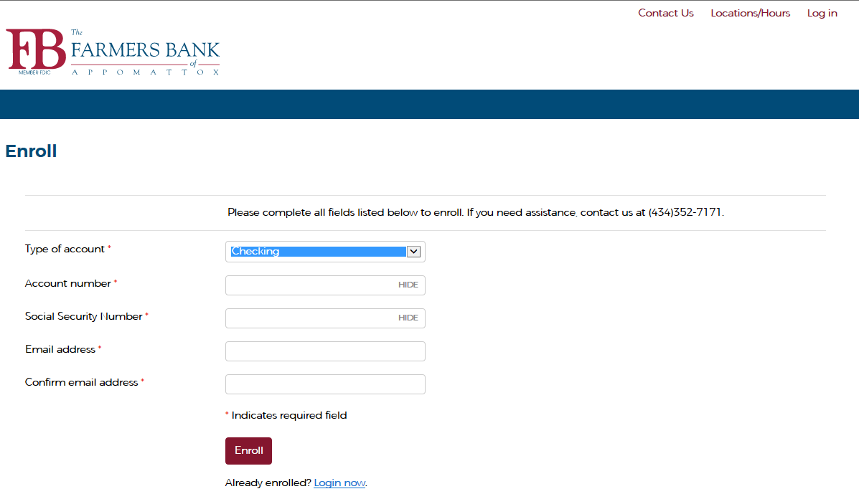

3. Read and agree to Terms and Conditions

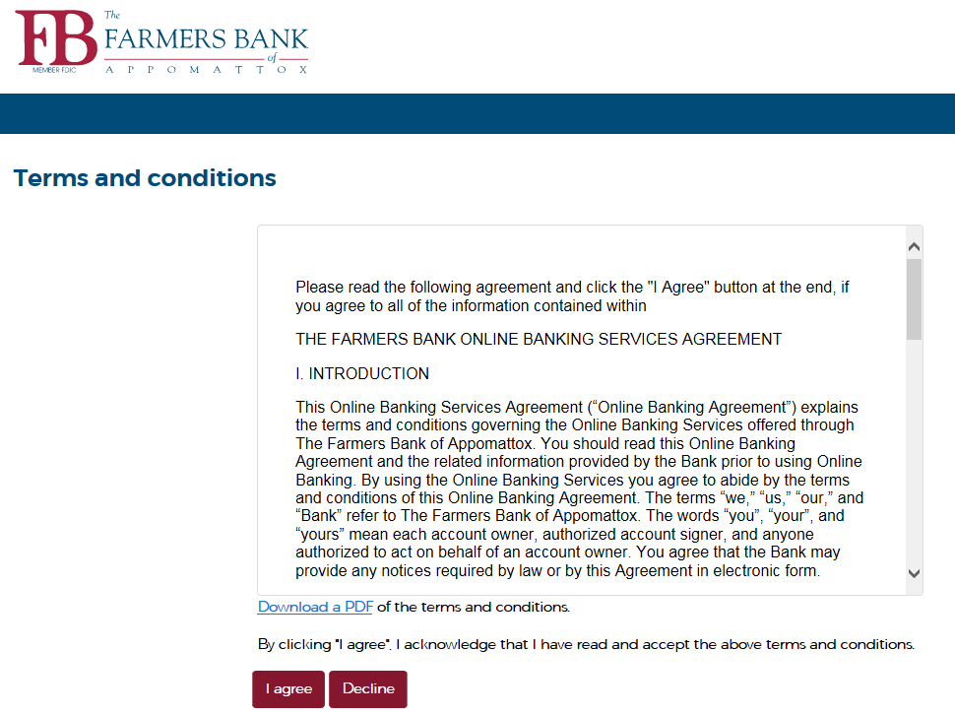

4. Create a username, then enter and confirm a password. Ensure your password meets the listed requirements.
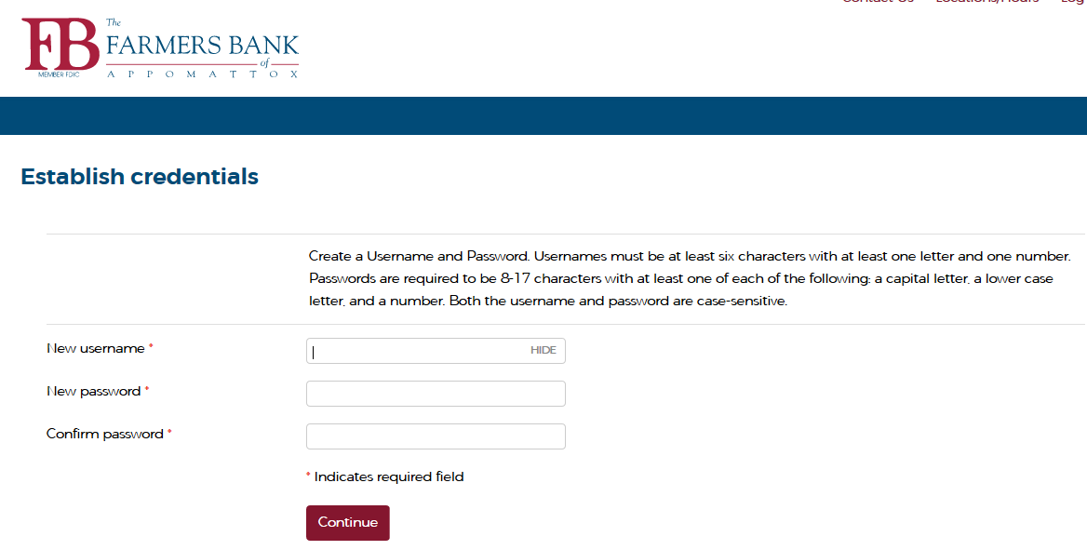

- Set up 3 challenge questions and choose whether to register computer to prevent being challenged in the future on your current device.
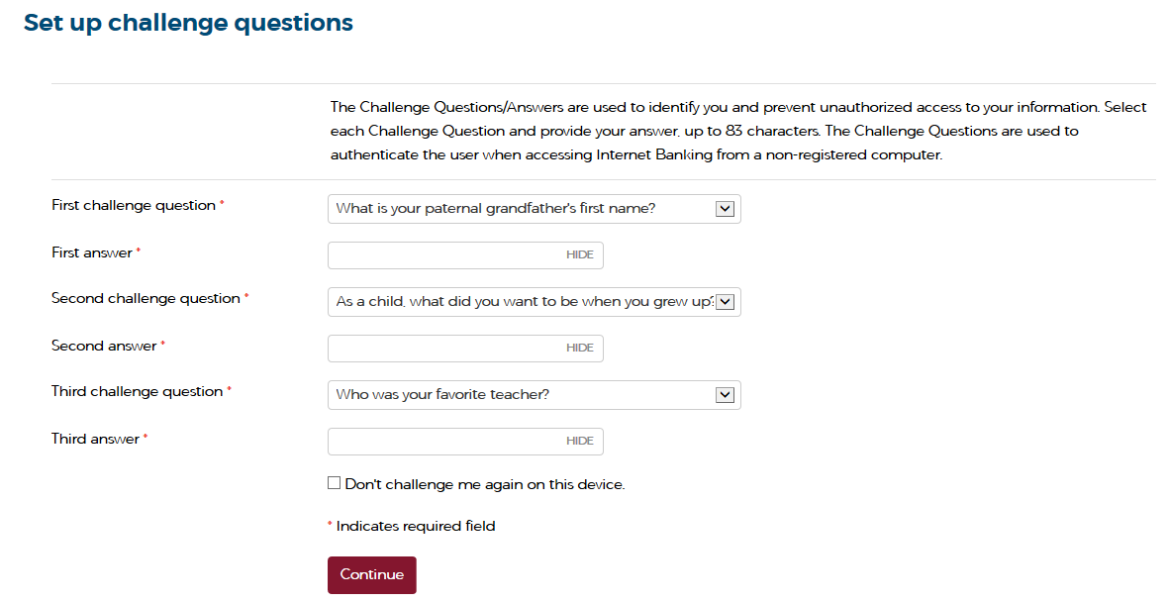

- Choose which accounts you would like to keep with paper statements, or to enroll in electronic statements. You may Enroll, Decline, or choose to set up at a later date. You must click on the Terms and Conditions link and accept IF e-statements are desired. A code will be provided at the end of the Terms and Conditions.
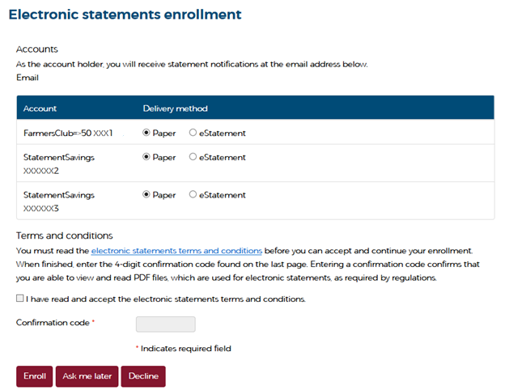

7. Choose whether to enroll in Mobile Banking. Options exist for banking by text message, but if you intend to use the app the quickest way to complete setup is to Decline at this screen and follow the mobile steps below.

Mobile Setup:
From your phone’s app store, search for FBVA Mobile, which will have an icon as below.
Direct app store links, depending on your device, are
Apple: https://apps.apple.com/app/id1537848462
Google: https://play.google.com/store/apps/details?id=com.farmersappomattox.mobile
Once the app is installed, either log in with your existing credentials and skip the next paragraph (if you already enrolled via web browser) or click the Enroll Now option.
You will need an account number, your SSN or other Tax ID Number, and an email to get started. You’ll be required to agree to terms and conditions to proceed, and next will be prompted to create a username and password that will be used on all future logins. Following that, you must select and provide answers to three challenge questions, and there will be a second set of terms and conditions specific to the mobile app. Last of all, you’ll have the option to turn on Live Updates, which will give the app permission to issue push alerts on your phone, if you desire.
At this point, you should be at the home screen and see your list of accounts – if you have questions, please give us a call at 434 352 7171 and someone will be glad to assist you.

