Thank you for your interest in using Farmers Bank’s mobile banking service. You must have an existing user ID for online banking before using mobile banking.
To enable mobile banking, begin by logging in with your existing user ID.
Next, click on Service on the left side of the page.
New options will expand under service; click the bottom one, Mobiliti.
After clicking Mobiliti, you will move to a new screen that shows your name and has an Enroll button. Click Enroll to proceed.
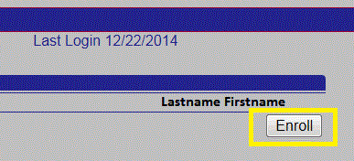

Next, a screen will display the terms and conditions for mobile banking. It may take several seconds for this screen to appear, so please be patient. If it does not load within 30 seconds to a minute, please close that window and click the Enroll button again. If this issue persists, your browser may be having compatibility issues with the online banking site – please contact the bank and someone should be able to help you get this working.
You must then check the box to accept the terms, which will cause a continue button to appear; click continue to proceed. You may scroll down in order to view the full terms or use the printer friendly button in the lower right to open in a new window if you wish to retain a copy for your records.

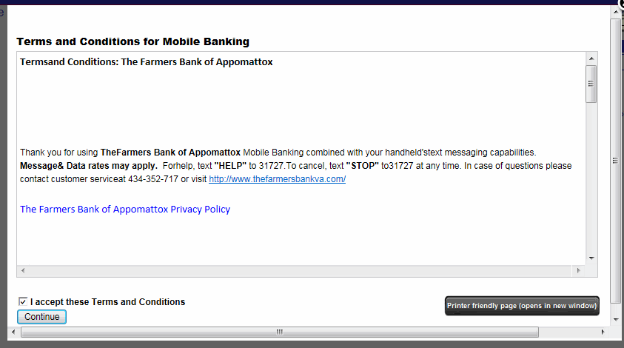

The next screen will display a large amount of information; you will need to scroll up and down to view it all. There will be instructions for obtaining and activating the mobile app, as well as the option to enable text banking or to request a link to the mobile browser version of online banking. 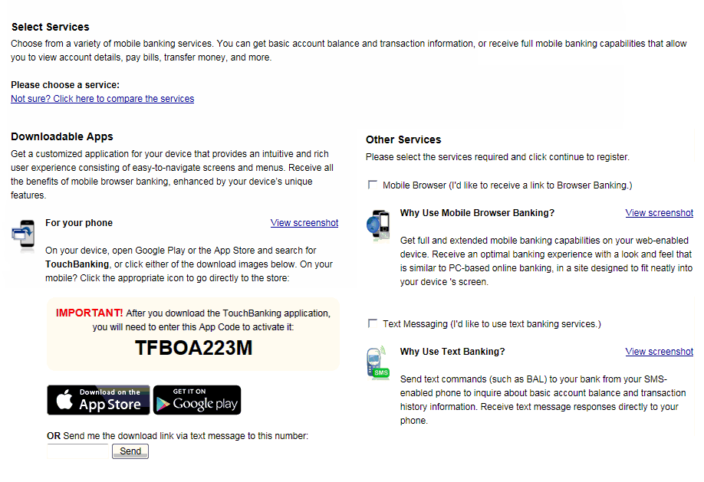
You may choose any or all of the available services, but must select at least one of Mobile Browser or Text Banking in order for the app to function. For mobile banking, you can request that a download link be sent directly to your phone, or can navigate to your app store and search for TouchBanking to find it for yourself – the app maker is Fiserv Solutions, Inc., and its icon is shown below.
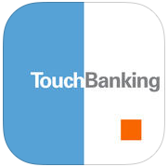
By choosing text banking, you will receive a text message with instructions for how to proceed. Similarly, if you choose the mobile browser option you will receive a link to the mobile site via text message.
Once you have selected your desired options and moved to the next screen, you will be taken to a screen to select your time zone and which account you would like to access through mobile banking. You can enter a nickname for your account(s), which will be used both as a name for the account and to select that account through text banking. Once you are finished on this screen, click continue.
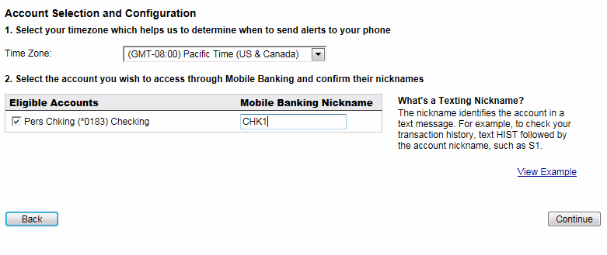

Now you will need to enter your phone number. If you have multiple devices, you will be able to select them later. Once you have entered the number, click continue to proceed.
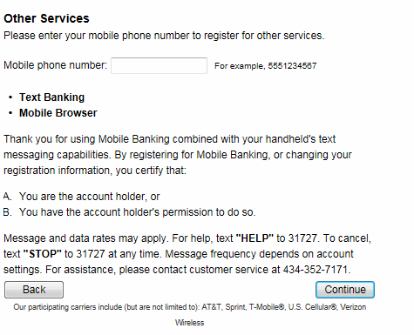

An activation code will now be sent to the phone number you entered. Once you receive the text, enter the code and click Activate.

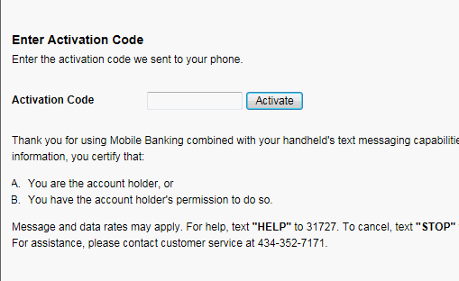

You will now see an Activation successful screen, and can finally click Go to Mobile Banking Main Menu to return to a list of options.
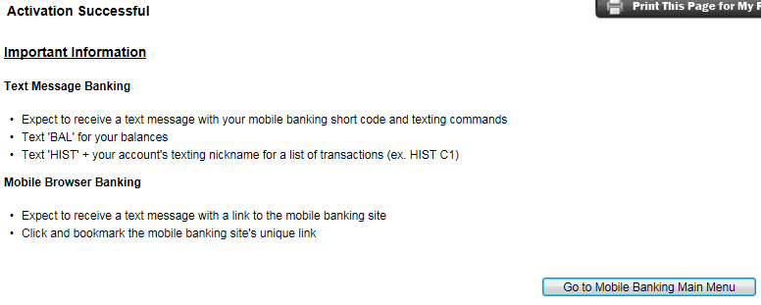
From the main menu, options to view My Devices, My Accounts, and My Profile will be available. In the future, you can reach this by logging in to online banking, then selecting Service, then Mobiliti, then Manage Devices.
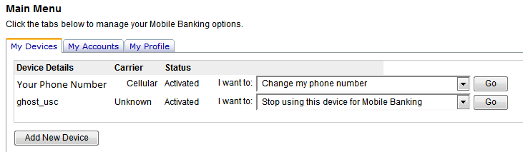
On the My Devices tab you will see any mobile numbers you are currently using, as well as an option to add a new device. You can choose to update your current phone number, add or remove mobile banking services, request another link to the mobile banking website, or disable mobile banking for the device. After selecting your desired option and clicking Go, you will be taken to a confirmation screen before any change is finalized
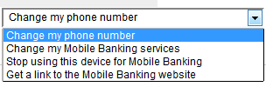

The My Accounts tab displays your list of accounts and allows you to choose nicknames for them. The nickname identifies the account in a text message. For example, to check your transaction history, text HIST followed by the account nickname, such as Checking1. Enter your desired nicknames, then click Update Accounts to make your changes.
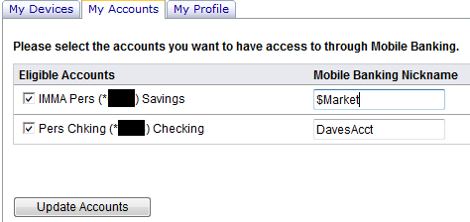

The My Profile tab displays your name and allows you to update your time zone.

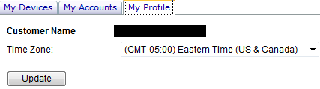

If you encounter difficulty with mobile banking at any step along the way, please contact us at (434)352-7171 or toll-free at 1-877-405-7797.

